**Task 4: Setting the Path for Java & Maven in Jenkins**

Setting paths for Java and Maven in Jenkins ensures Jenkins can locate these tools during job execution. This allows Jenkins to compile Java code, build projects, and manage dependencies seamlessly. Without these paths, build processes relying on Java or Maven would fail.

**I) Java Path Setting**

1. Successfully logged into the Jenkins Console

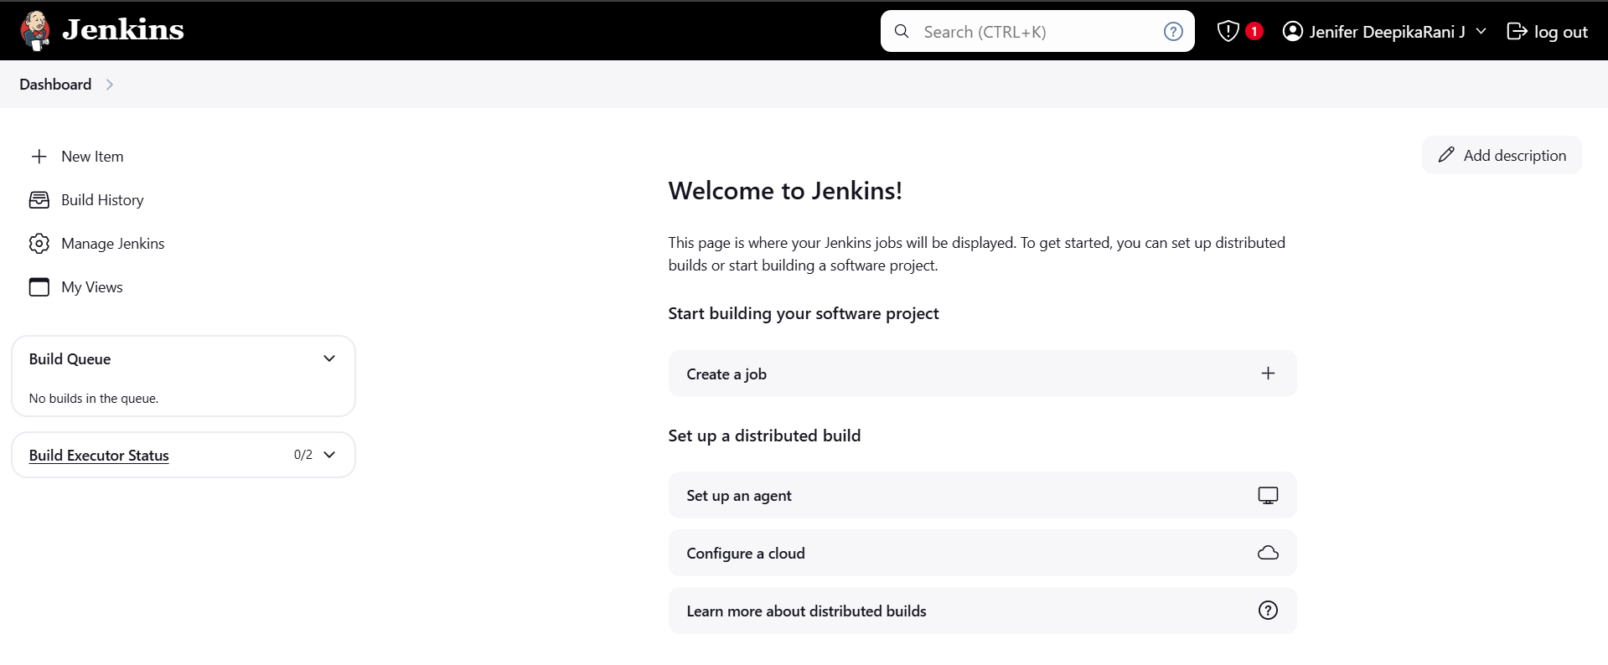

1. To set the path for Java, go to Manage Jenkins -> Tools -> JDK Installation

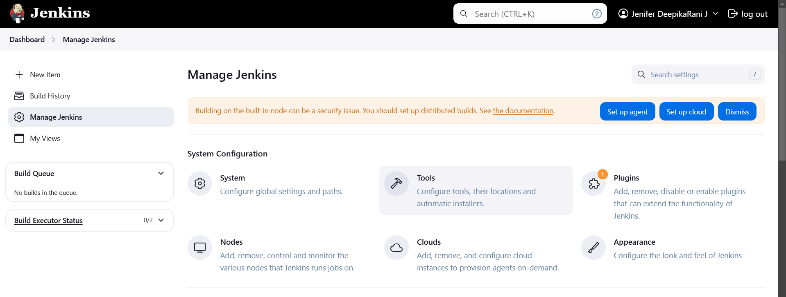

1. Add the Path of Java which is located in our laptop

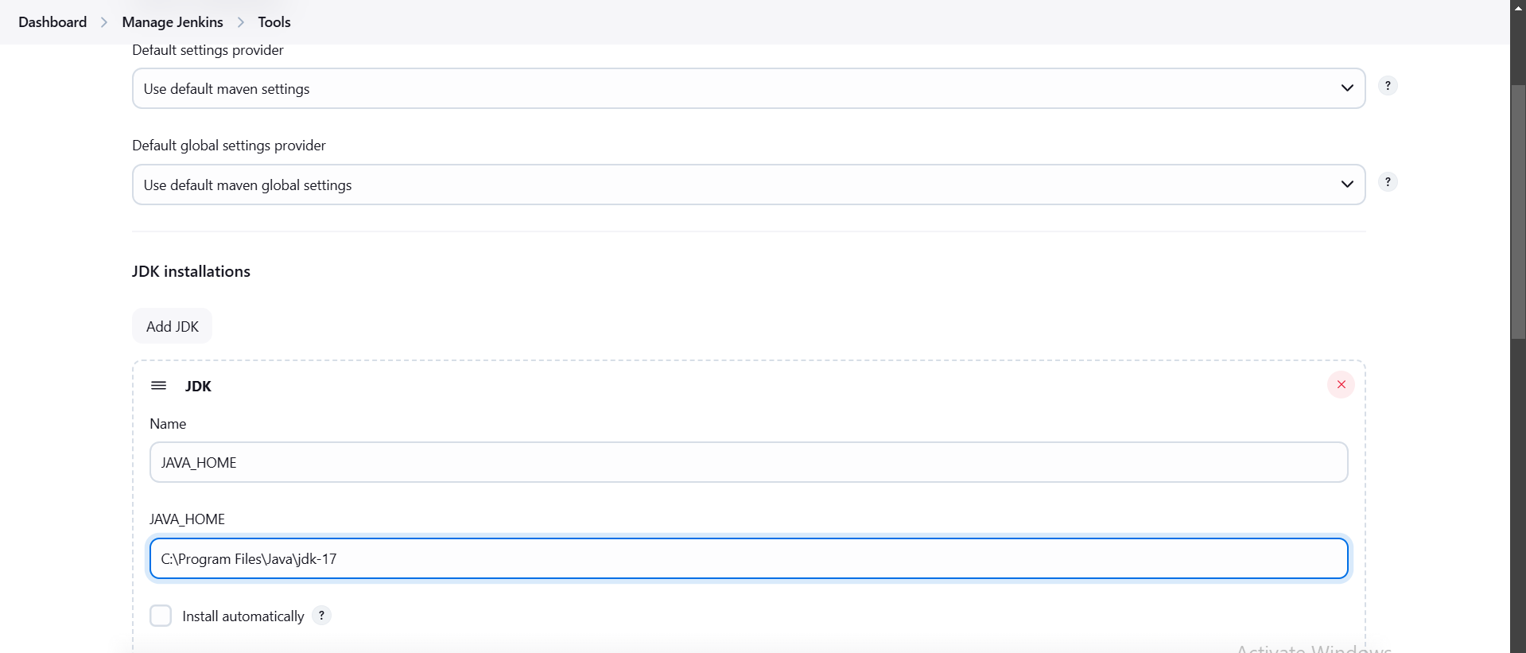

1. To check the path setting whether correct or not, I have given the command in Execute Windows batch command “java –version”. Then I have given Apply & Save.

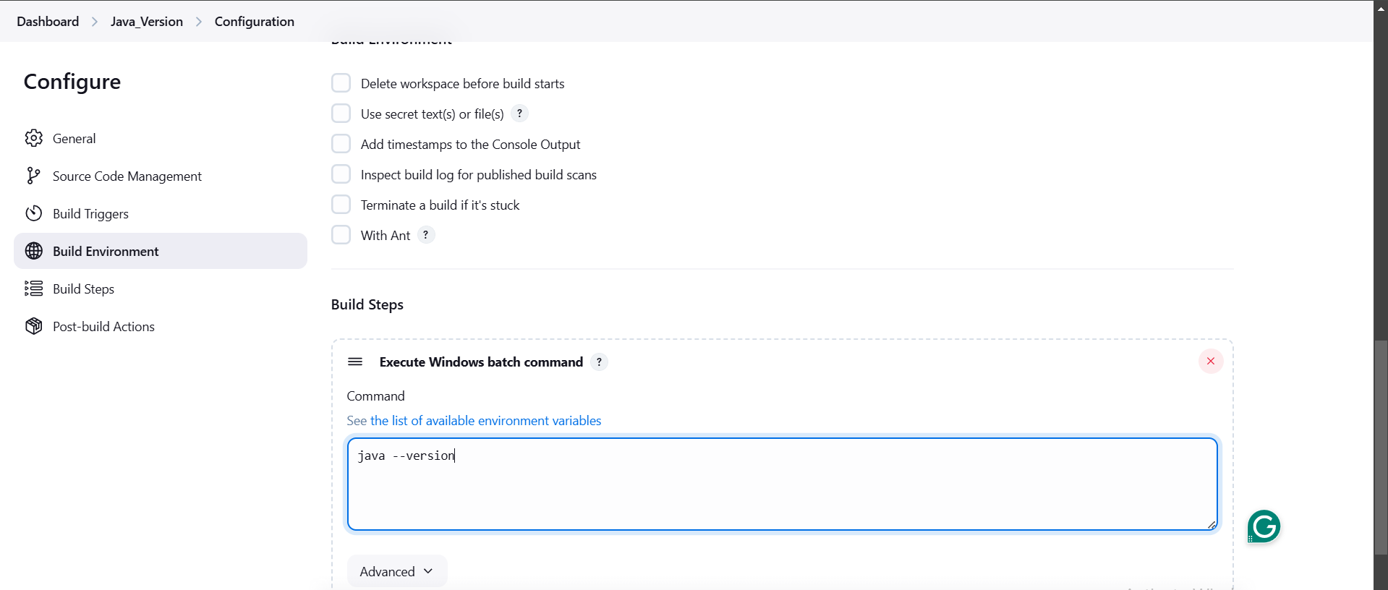

1. Click on the play button to build the project

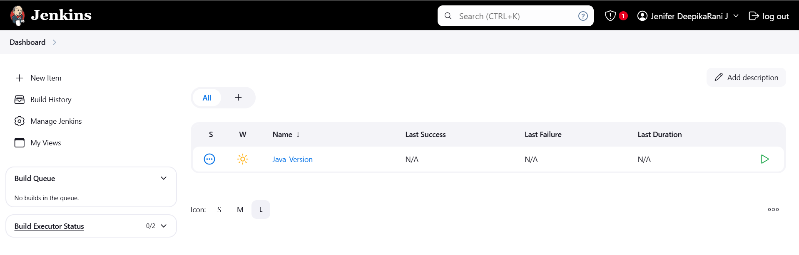

1. The Output

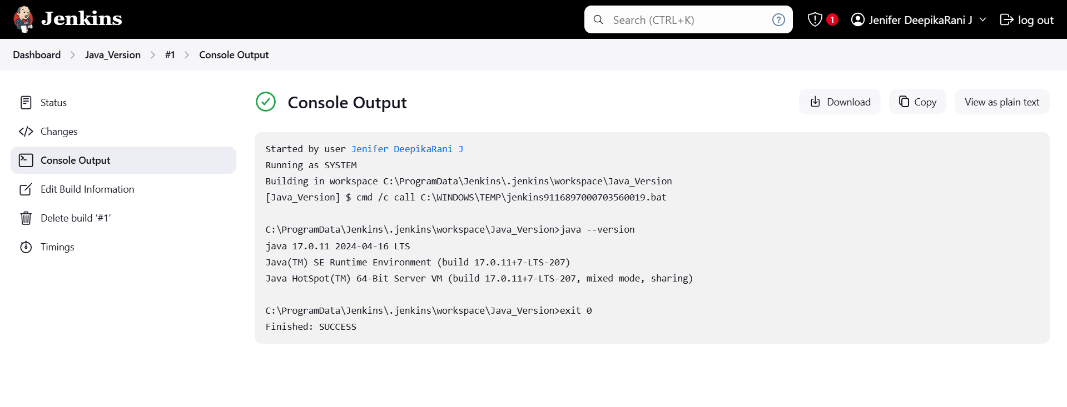

**II) Maven Path Setting**

1. To Set the Maven path, go to Manage Jenkins -> Tools -> Maven Installation And add the Path of Maven which is located in our laptop

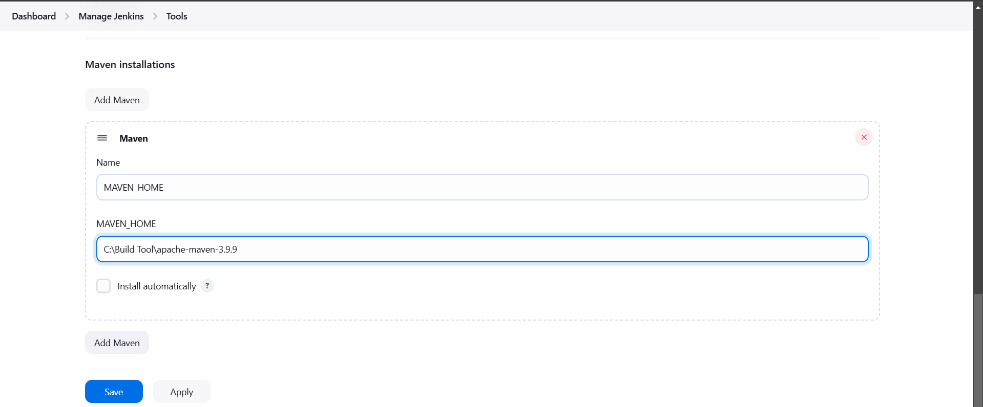

1. Then go to Dashboard->Maven Version(Bulid name)->Configuration, In Build Steps , Select Execute Windows batch command

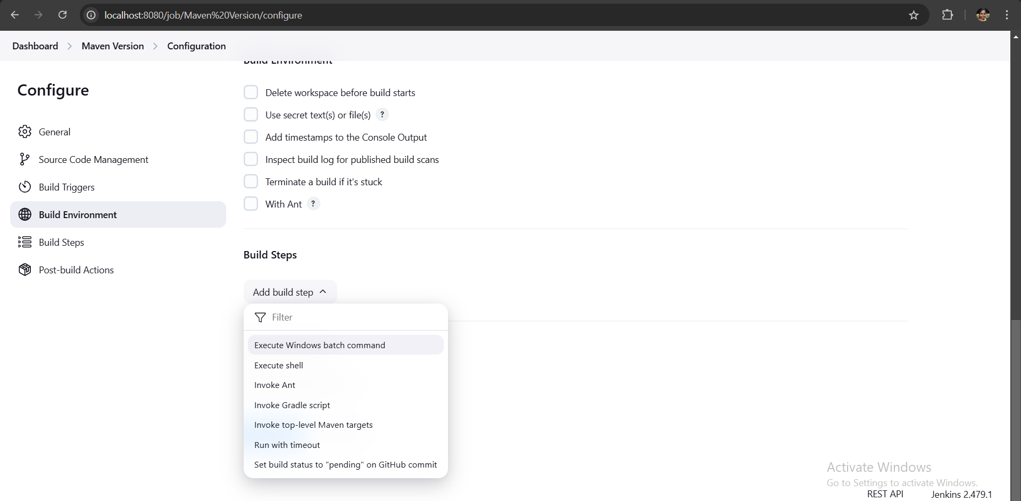

1. I have given the command “mvn –version” to check the given Maven path is whether correct ot not.

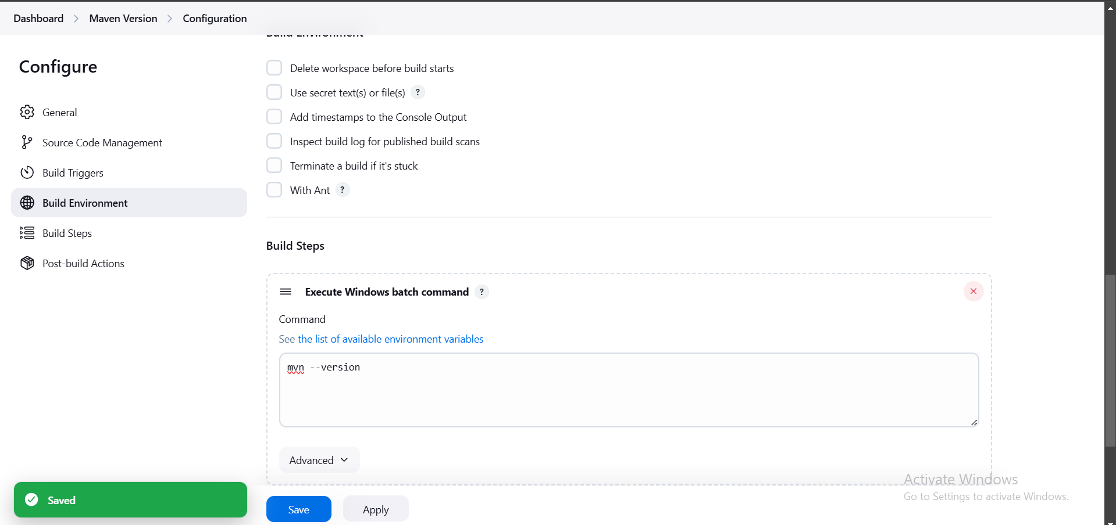

1. The Output

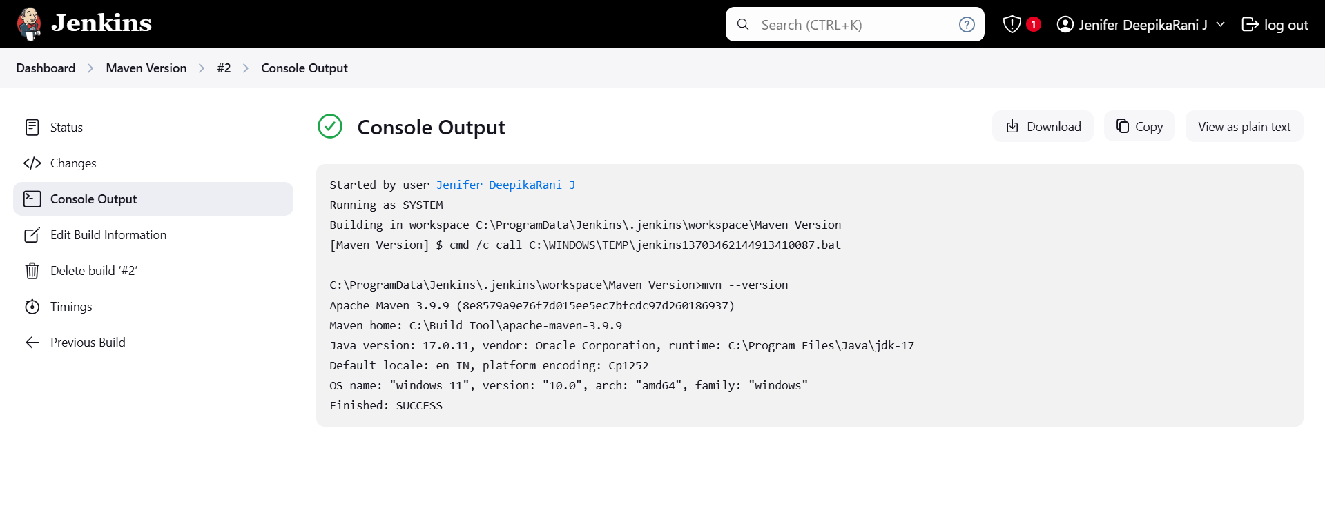

1. Hence, Java & Maven Paths Successfully Created and Checked.

